**SE103.3- System Analysis and Design**

|  |  |
| --- | --- |
| A picture containing clipart  Description automatically generated  Final report  **NSBM - SOC – PLY 18.2 - Group 02** | Client - Nawaloka Hospitals PLC  [OPD Management System]  **Lecturer- Mrs Dileeka Alwis**  **10021648 - H.N.H Liyanage**  **10026113 – K.Tharusha Kudagala (Team Leader)**  **10026140 – M.S.D Fernando**  **10026150 – Y.Raveesha Samarasinghe**  **10026475 – H.A.U Soysa**  **Date of submission: 17th May 2019** |

CLIENT OVERVIEW

* Client : Nawaloka Hospitals PLC
* Division : Out Patient Department (OPD)
* System : Patient Medical Information System

**Business Overview**

* Nawaloka Hospitals PLC has been a voice of private healthcare since its inception in 1985. From their humble beginnings, they have expanded to become the preferred private healthcare institution of the country. This is a Private Company with limited liability incorporated in Sri Lanka under the provisions of the Companies Act No. 07 of 2007. It is also domiciled in Sri Lanka and is a wholly owned subsidiary of Nawaloka Hospitals PLC.
* Nawaloka Hospital is one of Sri Lanka’s largest private hospitals and has created a chain of hospitals across the country. It is also the first hospital in Sri Lanka to introduce Intensive Care Units, Coronary Care Units, Laparoscopic Surgery and Thoracic Surgery.

**Address:** Nawaloka Hospitals PLC, No. 23, Deshamanya H K Dharmadasa Mawatha, Colombo 2.

Scope of Study

The main objective of this study is identifying the drawbacks of existing system and provide ways and means to overcome them by improving the current manual and semi-automated patient care system.

Hardware and Software requirements of the system will be analyzed and justified during our study.

This proposed semi-automated system will cover the following activities of Nawaloka Hospitals PLC.

* Patient registration
* Creating & Maintaining patient profiles
* Medicine ordering system

Details of the existing system

When we study the OPD system of the Nawaloka Hospitals PLC, they are using manual and semi-automated systems.

**Manual System**

* Placing orders in pharmacy

**Semi-automated**

* Registering new patients
* Maintaining Diagnostic reports of the patient
* Prescribing medication & treatments

Drawbacks of the existing system

When we are studying their system, we found some drawbacks of their system, but currently their existing system is enough for their management, but at the future they must extend their boundaries because they want to have Joint Commission International accredits.

* There are some manual subsystems that needs automation.
* Patients need to wait a considerable amount of time to have the medicine from the pharmacy.
* Semi-automated systems are currently under experimenting phase.
* Not alerting the patient about the prices for medication at hospital pharmacy.

Details of the proposed system

To solve difficulties in the existing system we proposed a new system to extend their capabilities. And we are automating the current manual subsystems. The new system should have the following functions:

* Creating a unique profile for each patient (UPIN - Unique Person Identification Number).
* Realtime token generation in OPD
* Updating the patient’s profile with undergoing medical procedures, reports and prescriptions.
* Patients can order the medications from the pharmacy via responding to the message send by our system.

expected benefits from the proposed system

* **Less Time Consumption**

Patient doesn’t need to go to the pharmacy to order medication.

* **Efficient Observation making**

Hospital management can count the number of patients who has visited the OPD and Pharmacy.

* **High Accuracy**

Patients will get alerts with the accurate prices of medication from pharmacy.

* **Efficiency and ease of access**

Patient only needs to confirm the alert if they want to place an order.

* **Security**

Medication price details are notifying via an SMS, but to place the order, the patients need to confirm it first with a pin previously given to them at the registration.

Fact finding methods

**Interview 01**

* Appointment date: 16th May 2019
* Time: 9:30 AM – 10:00 AM
* Client: Mr. S. H. Nanayakkara - Assistant manager (IT Department)

Only the leader of our team had granted access for the meeting. There he gave a brief explanation about NSBM, SAD module and the Project. Mr. Nanayakkara gave the leader some information about the IT Division’s role in the Hospital and agreed to have another meeting on 24th May 2019 and introduced the leader to Mr. Varuna.

**Interview 02**

* Appointment date: 16th May 2019
* Time: 10:00 AM – 11:00 AM
* Client: Mr. Varuna Colombarachchige (Mobile Application Specialist)

The leader introduced us to Mr. Varuna, and we discussed about the Systems in Nawaloka Hospitals PLC. There he gave us an explanation about the vast parameter of their system. We tent to focus more on OPD Management System, and we asked further details about that.

**Interview 03**

* Appointment date: 24th May 2019
* Time: 10:00 AM – 10:30 AM
* Client: Mrs. Rasika Gamage (Application Specialist)

The whole team had the opportunity to have the discussion with Mrs. Rasika. Their we showed her our basic plan and she gave us some more information about the UPIN (Unique Patient Identification Number) and the process at the Pharmacy. She ensured that the computer literacy of OPD Doctors and Pharmacists is enough to deal with our proposed system.

Finally, she forwarded us to Mr. Saman Abrew (System Analyst) for the site visit.

**Site Visit (Observation)**

* Appointment Date: 24th May 2019
* Time: 10:30 AM – 1:00 PM
* Guide: Mr. K. Saman Abrew (System Analyst)

With the guidance of Mr. Saman, We were able to observe the whole procedure.

* Manually filling the registration form.
* Creating a profile for the patient and given a UPIN card.
* How the triage checks the patient and screens the patient’s status. (In an emergency they directly forward the patient to ETU (Emergency Treatment Unit).
* A sticker is provided to each patient with their UPIN.
* The Doctor diagnosed the patient and update the patient’s profile.
* Prescribed medicine is printed to a prescription sheet.

After the site visit, Mr. Saman showed us how all the technical things are controlled by the IT Division.

* Created a UPIN for the Leader.
* Published an UPIN card to him.
* Diagnosed him and updated his profile. (OPD Dr. A.P Kumarapperuma)
* Prescribed some medicine to him and printed out the prescription sheet. (Doctor)
* Showed their online medicine ordering system for inward patients.
* Requested a drug from the pharmacy online.
* Showed how the pharmacy operates the online requests.

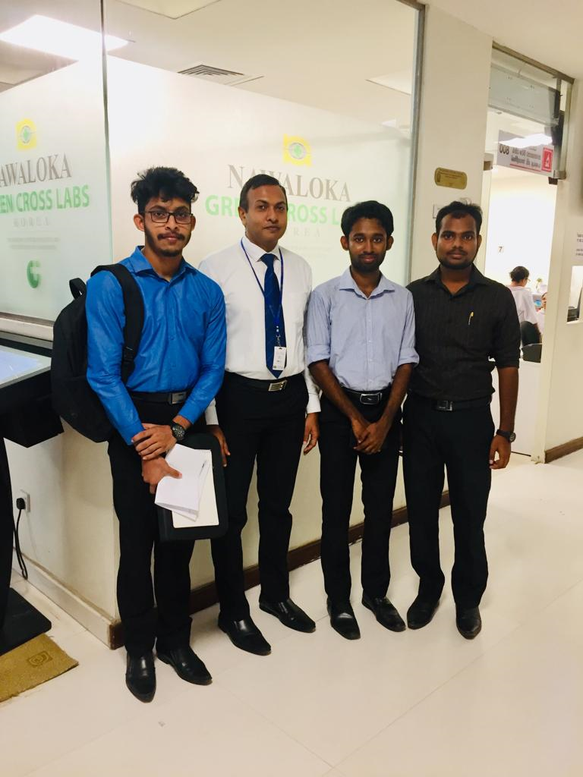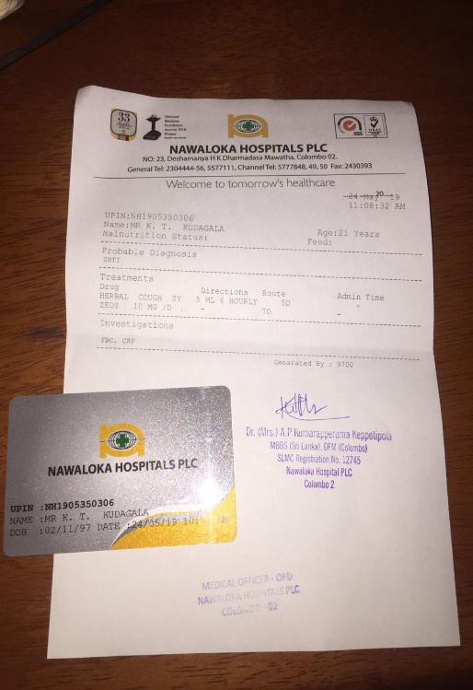

documentary review

functional Requirements

**Registrations**

* From the reception desk, they can add new patients to the system.
* To each patient an UPIN Card is given and add it to the patient´s record. This ID must be used by the patient throughout his/her stay in hospital.
* A card is printed with the patient´s UPIN, patient´s name, card issued time and date, and Date of Birth of the patient and with a barcode and some emergency numbers of the hospital at the back of the card.

**Database**

* Patient´s mandatory information – Each patient shall have the following information: NIC no, first name, last name, phone number, email address, address, city, patient´s UPIN. Databases are a part of HMS (Hospital Management System)

**Prescription receipt**

* Receipt is generated on patients about the following information: UPIN, Name, Age, malnutrition status, diagnosis, treatments (drug, Directions, Route, admin time) investigations.

**Design Constraints**

* Database- The system shall use the MySQL Database, which is open source and free.
* Operating system- The development environment should be windows 7 and Windows 10.

non-functional Requirements

* **Reliability** - The reliability of the purposed system is higher, and patient’s medical information is secured. System control the accessibility of data retrieving and updating.
* **Backup -** The system facilitates data backup procedure.

**Accuracy** – Patients will get alerts with the accurate prices of medication from pharmacy.

* **Ease of use** - The system is easy to maintain, manage, update, retrieving data and analysis.
* **Availability** - A notification will always be send to the patient about medication details.
* **System security** - The system has a good level of security system. patient's privacy is secured. Information cannot be obtained outsiders. Only authorized people can access it.
* **Efficiency and speed -** The system will be reduced time wasting. Currently, when people buying medicine must wait in line for a while at the pharmacy. In the purposed system, the pharmacist will be got an online order through the patient’s mobile. After, pharmacist accepted it and must fulfil it. Finally, the patient comes to the pharmacy and will be able to pay and take it.
* **Data retention** - Each registered patient computerized by using UPIN. After the patient's every medical information is recorded.
* **Usability** - Software can be used again and again without distortion.
* **Maintainability** - The ability to maintain, modify information and update fix problems of the system.
* **Accessibility** - Administrator and several other users can access the system, but the access level is controlled for each user according to their work scope. The pharmacist only can access to the prescription, not to the medical history of patient.

detailed budget

|  |  |  |  |
| --- | --- | --- | --- |
| Date | (+) Funds | | Balance (LKR) |
|  |  |  |  |
| 09/05/2019 | Collect (200.00*5) | | 1000.00 |
| 23/05/2019 | Collect (400.00*5) | | 2000.00 |
|  |  |  | 3000.00 |
|  |  |  |  |
|  |  |  |  |
|  |  |  |  |
|  |  |  |  |
|  | (-) Expenses |  |  |
|  |  |  |  |
| 10/05/2019 | Transport | 300.00 |  |
| 16/05/2019 | Transport | 450.00 |  |
|  | Snacks | 150.00 |  |
|  | Transport | 710.00 |  |
|  | Snacks | 470.00 | [2080.00] |
| 13/06/2019 |  |  | 920.00 |

risks involved

* Their existing system is highly complex, in that situation when we implement our proposed system it might cause errors and crash the entire system.
* They are using a web-based system, but our proposed system is based on C# so there might be a compatibility risk.
* It’s a huge challenge for us to make such a complex system with the given time.
* We have insufficient knowledge and resources to make a fully functional system
* It might take some time for users to adjust to the new system because they are currently using a web-based system.
* Risk of data redundancy and id issuing errors.
* When there’s issues in the SP (service provider) whom we send SMSs, or the SPs of the patient, notification system might delay or not work

System design